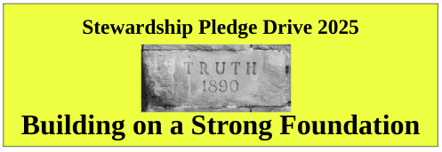

The First Unitarian Church of Oakland is built on a Strong Foundation. Our historic building, built in 1890, has survived two earthquakes, two world wars, a Depression and most recently a Pandemic. Our congregation has seen generations of members and friends pass through our sanctuary. We’ve hosted Presidents, Spiritual Leaders, UNESCO founding meetings and too many memorial services to count. We’re still here.

Coming out of Pandemic has been a challenge for all churches and ours is no exception. And we’re still here. Our New Member Service welcomed many looking for a liberal, covenantal church home into our congregation, including young families with their amazing children. And that’s one huge reason why we’re still here.

Each year we ask our members and friends to make a financial commitment, a pledge, to make sure we are still here. Your pledge is used for the operating costs for the coming year, money to pay our minister, staff, utility bills, insurance, professional services such as bookkeeping, payroll, equipment inspection and maintenance, and our contribution to our national organization the Unitarian Universalist Association.

We’re asking all who made pledges last year and this year to renew their pledge for the coming year, 2025. Money from you pledges pay for almost sixty percent (60%) of our operating expenses. Pledge income allows us to maintain our current staff levels and retain our Contract Minister Rev. Laurel Liefert. And if you are able, please consider increasing your pledge by three percent (3%) to help with Cost-of-Living increases for our valuable staff.

You can make a pledge two ways. Enclosed is a pledge card which you can fill out, sign and return in the offering plate, hand it to a Board member, or return by mail. Or you can go online to our website and click on the *Building a Strong Foundation* image to bring you to a page with a link to the online pledge form. We’re asking everyone to renew their pledge, even if you are a Sustaining Pledger.

Below is a high level view of our income and expenses to give you a feel for our income and expense categories. If you would like more detailed information ask any Board member and we’ll get it to you.

We’ve shortened the Pledge Drive period this year and ask everyone to turn in their Pledge Card or make an Online Pledge as soon as possible. And as we’ve done in recent years, we will end our formal Pledge Drive period on Sunday, November 3, 2024 with a celebration lunch.

Thank you in advance for your pledges, donations and continued generosity.

Sincerely, Your Stewardship Team (which is your Board of Trustees)

