Adult Faith Development
Fall 2019

Worship - Worship is central to
faith development. At 10:20 am
on Sunday mornings we pause, celebrate, reflect, and recommit
to our spiritual lives and the change, we want to be in the world.

Spiritual Practice - All members
are encouraged to commit to a regular spiritual practice, such as meditation, prayer, yoga, interplay, memorizing poetry, walking, music, justice work, or spending time in nature.
Wi$dom Path - with Pastor Theresa and Rev. Sheri Sept. 14, 22, Oct. 6, 13, at 9-10 AM in the 3rd Floor. Participants build awareness of their own “money story” and explore their own attitudes and experiences with money, then delve into ways to align faith, values, and a sense of a life calling with their financial ways of being. Contact:
revsheri@uuoakland.org

Spiritual Practices for Courageous and Compassionate Living
with Rev. Mary Foran and Affiliated Community Minister. 8 sessions, TBA.
This group aims to build mutual commitments for courageous
and compassionate living, where liberation for all is the goal, through listening and speaking, silence, ritual and prayer, inviting authenticity, and cultivating trustworthiness. Contact: mpforan@earthlink.net

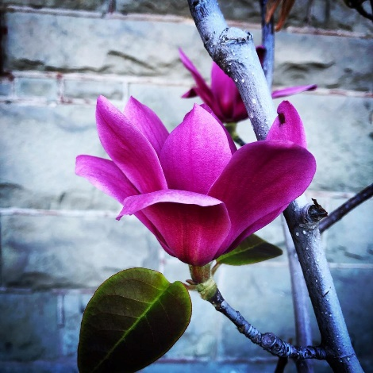

We invite you to join us as we grow in faith. All are welcome!

Wisdom of World Religions Discussion Group
3rd Saturdays at 10:30 AM in the Library. The third source of UUism acknowledges the wisdom of many religious traditions around the world. Participants investigate some of those sources of wisdom and see how they can illuminate our understanding of the seven principles of Unitarian Universalism. Contact Anthony McHugh:
anthonybenjaminmchugh@gmail.com

Disability Identity Discussion Group
Meets 3rd Sundays after the worship service at 12 PM in the Library. This group is for people who identify as having a disability, obvious to others
or not, and together we share our personal experiences, offer mutual support and discuss how the church can become more inclusive of people with all disabilities. Contact Debby Kaplan:
debby@swansway.com

Pagan Interest Group - Circle of Oak
Meets 3rd Sundays at 12:00 PM. The group explores the world's Earth-based spiritual paths based on
the religious traditions of members' expertise. The group welcomes those grounded in Earth-centered traditions of Africa, Asia, Oceania, and the Americas who wish to
share and explore together.
Contact Piper Rowanoak:
airtribepriestess@gmail.com

Church Book Group - Come to the Stoper’s home on the 4th Thursdays of each month, 7:30 - 9:30 PM to discuss nonfiction books that deepen our understanding and commitment. Drop-ins are always welcome. Contact Emily Stoper: bookgroup@uuoakland.org

Many Paths: A Faith Sharing Series
Occasional 4th Sundays fallowing
the services, in the Starr King room.
Individual members share their stories of their faith path, followed
by conversation/Q&A. For speaker ideas or questions, please contact Rev. Sheri: revsheri@uuoakland.org.

Meditation Sitting Group (Sangha)
3rd Mondays 7:15 - 8:30 PM, private home that is BART accessible in Rockridge. We welcome meditators
of all backgrounds and experience levels. Silent 40-minute meditation, followed by check-ins and tea.
Contact Carol Emert, meditation@uuoakland.org

Orientation to Membership Workshop - 4th Sunday of each month, 12 noon, in the Starr King Room. Designed primarily to help newcomers decide whether
Unitarian Universalism and the First Unitarian Church of Oakland are right for them. Contact Rev. Sheri, revsheri@uuoakland.org

Covenant Groups - Small groups
who meet to deepen relationships and reflect on the spiritual themes of the month. To join a Covenant Group. Contact Emily Stoper, covenantgroups@uuoakland.org

First Sundays Racial Identity Caucusing and Potluck - 1st Sundays in the Starr King room for 2 hours; we begin with a potluck approximately 15 minutes after worship. We gather to expand our understanding of and provide mutual support for the anti-racism and multicultural work of building the beloved community. Please join us in this "heart" work
and help increase justice and equity. We present interactive programs and break out for racial identity caucusing that brings all attendees together. Child care available with advance notice.
For Contact the Journey Toward Wholeness Transformation Team, jtw@uuoakland.org

Poetry Circle - 4th Sundays 9:30 - 10:10 AM in the library at the church. Bring a favorite poem including ones you’ve written. Contact Ron Weisberg, poetry@uuoakland.org

For more information about church events please go to our Church Calendar
https://uuoakland.org/calendar/

Adult Faith Development

Fall 2019

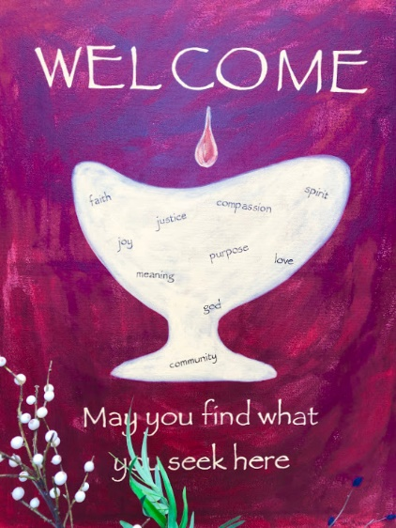

First Unitarian
Church of Oakland
685 14th St. Oakland, CA
www.uuoakland.org

Revised
9/2019

